

Web Programming Project
Recipes Website

Team Members
Retaj Ali: 231005689
Rawan Atef: 231005789
Mohamed Shahen: 231006169
Supervised by
Dr: Hossam Selim
ENG: Mohamed Moheeb

Introduction

Recipe Delight is a fully functional, user-friendly website that allows users to explore, save, and manage cooking recipes. The system is divided into two main roles: Users and Admins.
- Users can register and log in to browse a collection of categorized recipes (like breakfast or beverages), save their favorites, and manage them through a personalized profile.
- Admins have access to a secure dashboard where they can view site analytics using charts, manage user roles, remove saved items, and monitor activity.
The website uses HTML, CSS, PHP, JavaScript, and MySQL as the core technologies, with Chart.js for data visualization. A session-based login system ensures data protection and personalized access

Problem definition
Many existing recipe websites are static and lack personalization features. Users can only view publicly listed recipes without any way to interact with them. These platforms often don’t include account creation, recipe saving, or any form of user engagement. As a result, users can’t save their favorite meals, track their history, or have a profile to manage their preferences.
In addition, administrators have limited visibility and control. Most sites don’t provide:
- Real-time statistics about recipe categories
- User activity logs (like who favorited which recipe)
- The ability to promote or demote users
- Tools to manage the website content dynamically
We saw this gap as an opportunity to build a more interactive and organized recipe system.
Recipe Delight solves this problem by:
- Allowing users to register/login, save their favorite recipes, and manage them in a profile
- Using session-based login to keep users connected across pages
- Providing an admin dashboard to manage users and content efficiently
- Displaying real-time statistics with visual charts for better decision-making
This project is suitable because it combines user engagement, admin control, and a modern user interface, making the cooking experience more personal and functional.

Project’s functionality

User Functionalities
- User Registration & Login
  - New users can create an account by providing a username, email, and password (with password validation: min. 8 characters).
  - Existing users can log in using either their email or username.
  - On successful login, a PHP session starts and the user is redirected to the recipe menu page.
- Session-Based Access
  - Once logged in, users can access special features like viewing recipes, adding to favorites, accessing their profile, and navigating to the About page.
  - If the user is not logged in, these buttons are hidden, and the system shows only the login/register options.
  - Sessions persist until the user logs out.
- Recipe Menu Page
  - Recipes are displayed in categorized sections (e.g., Breakfast, Beverages).
  - Each recipe includes:
    - High-quality image
    - Recipe title
    - Button to “Add to Favorite”
  - When clicked, the button changes to “Added” and stores the recipe in the database for the logged-in user.
- Search for Specific Recipes
  - A search bar allows users to search for recipes by name.
  - The results update in real-time to help users quickly find dishes they want.
- About Page
  - Introduces the creators with pictures and bios (e.g., Nour and Sara).
  - Adds personality and story to the website, making it more engaging.
- Profile Page – “My Profile”
  - Displays the user's:
    - Name
    - Email
    - Number of saved recipes
  - All saved recipes are listed with:
    - A “View” button to read the full recipe
    - A “Remove” button to delete it from their saved list
    - A “Back to Recipes” button lets users return to the main menu

Admin Functionalities
- Admin Login
  - Admins have a dedicated login portal using credentials from the admins table in the database.
  - Upon login, they are redirected to the admin dashboard.
- Admin Dashboard Overview
  - Displays key stats:
    - Total Users
    - Total Favorites
    - Top Favorite Recipe (based on how many users saved it)
  - Shows a Chart.js pie chart of recipe category statistics
  - Logs recent user activity (account creation, recipe saves)
- Manage Users Page
  - Lists all registered users with:
    - ID, Username, Email, Current Role
    - Buttons to Promote or Demote roles between User and Admin
    - Identifies the current logged-in admin
- Manage Favorites Page
  - Displays a table of all saved recipes across all users
  - Admin can Remove any saved recipe from the database directly
- User Search Function
  - Admins can search for specific users by username or email
  - Helps locate specific user accounts quickly
- Visit Site Button
  - Allows admins to visit the public website (menu page) directly

Diagrams

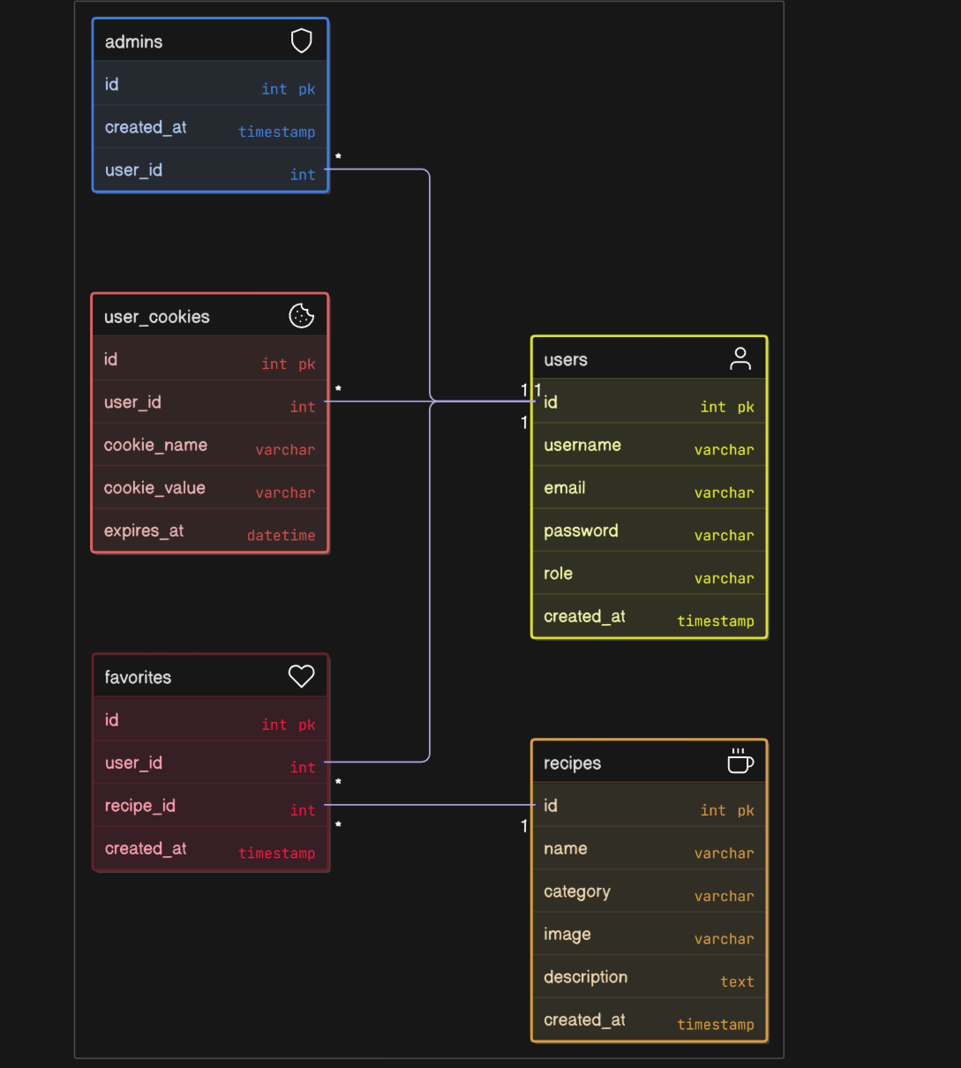
Bonuses

jQuery Integration
- Admin Dashboard:
jQuery is used in the Admin Dashboard to simplify event handling and enable dynamic behaviors such as button actions, data updates, and interface responses without reloading the page.
- All Recipe Pages:
Each individual recipe page (such as Chocolate Chip Cookies and Chicken Alfredo Pasta) uses jQuery to:
  - Handle print button clicks smoothly
  - Improve responsiveness and reduce code complexity
Cookie Usage
- Menu Recipes Page:
Cookies are used to personalize the experience. For example, if a returning user has a stored username cookie, the site displays a friendly message like: Welcome back. [username]!

